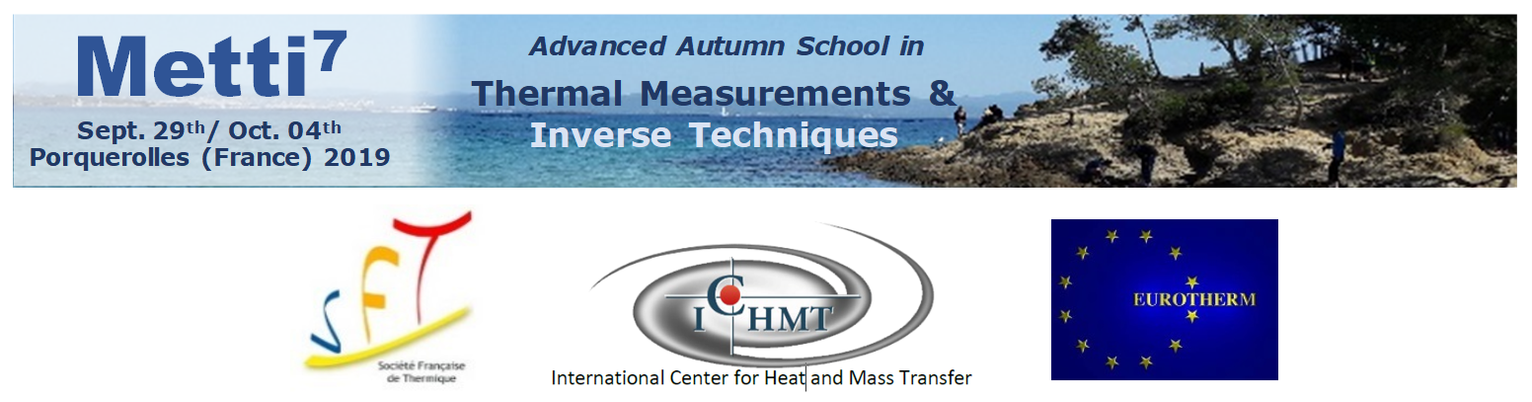
PROCEEDINGS
Foreword: Finding ‘causes’ from measured ‘consequences’ using a mathematical model linking the two is an inverse problem. This is met in different areas of physical sciences, especially in Heat Transfer. Techniques for solving inverse problems as well as their applications may seem quite obscure for newcomers to the field. Experimentalists desiring to go beyond traditional data processing techniques for estimating the parameters of a model with the maximum accuracy feel often ill prepared in front of inverse techniques.
In order to avoid biases at different levels of this kind of involved task, it seems compulsory that specialists of measurement inversion techniques, modelling techniques and experimental techniques share a wide common culture and language. These exchanges are necessary to take into account the difficulties associated to all these fields. It is in this state of mind that this school is proposed.
The METTI Group (Thermal Measurements and Inverse Techniques), which is a division of the French Heat Transfer Society (SFT), has already run or co- organized six similar schools, in the Alps (Aussois, 1995 and 2005), in the Pyrenees (Bolquère-Odeillo, 1999), in Brasil (Rio de Janeiro, 2009), in Bretagne (Roscoff, 2011) and in Pays Basque (Biarritz, 2015). The seventh edition of the school was again open to participants from all over the world with the support of the Eurotherm Committee.

Scientific coordination | Logistics | Secretary
Jean-Luc BATTAGLIA – I2M Bordeaux France  Université de Bordeaux – ENSAM & CNRS  jean-luc.battaglia@u-bordeaux.fr | Fabrice RIGOLLET – IUSTI Marseille – France  Université d’Aix-Marseille & CNRS  fabrice.rigollet@univ-amu.fr | Joyce Bartolini, IUSTI, Marseille  joyce.bartolini@univ-amu.fr  Université d’Aix-Marseille & CNRS
Denis MAILLET – LEMTA Nancy France  Université de Lorraine & CNRS  denis.maillet@univ-lorraine.fr | Jean-Laurent GARDAREIN– IUSTI Marseille France  Université d’Aix-Marseille & CNRS  jean-laurent.gardarein@univ-amu.fr

NB: The next edition of this school, Metti 8, will take place from Sept. 24 to 29, 2023 in the “Ile d’Oléron” in France, see https://metti8.sciencesconf.org/

Lecture 1 - Getting started with problematic inversions with three basic examples
P. Le Masson, O. Fudym, J.-L. Gardarein, D. Maillet
Lien vers fichier: L1-Le Masson final-reluJLB.pdf

Lecture 2 - Advanced measurents with contact in heat transfer: principles, implementation and pitfalls
F. Lanzetta, B. Garnier
Lien vers fichier: L2-Lanzetta Garnier final-reluJLG.pdf
Lecture 3 - Basics for linear inversion: the white box case
F. Rigollet, D. Maillet
Lien vers fichier: L3-Rigollet final_JLB+DM+TP+FR.pdf
Lecture 4 - Measurements without contact in heat transfer

Part A - Radiation thermometry : principles, implementation and pitfalls
J.C. Krapez
Lien vers fichier: L4-part A-KRAPEZ apres coup.pdf

Part B - Quantitative Infrared Thermography
H. Pron, L. Ibos
Lien vers fichier: L4-part B-Ibos final.pdf
Lecture 5 - Nonlinear parameter estimation problems: tools for enhancing metrological objectives
B. Rémy, S. André and D. Maillet
Lien vers fichier: L5-Rémy et al final_JLB.pdf
Lecture 6 - Inverse problems and regularized solutions
J.C. Batsale, O. Fudym, C. Le Niliot
Lien vers fichier: L6-Le Niliot final-relu DM-JCB-V4-8Juin&19Juillet22.pdf
Lecture 7 - Types of inverse problems, model reduction, model identification
Part A – Experimental identification of low order model
J.-L. Battaglia
Lien vers fichier: L7-part A-Battaglia final-ReluDM2fois&JLB-25Juillet22.pdf

Part B – Modal reduction for ther Y. Jarny, D. Mailletmal problems: Core principles and presentation of the AROMM method
F. Joly, Y. Rouizi, O. Quéméner
Lien vers fichier: L7-part B-Quemenerfinal_ReluDM.pdf

Lecture 8 - Function estimation in inverse heat transfer problems
Y. Favennec, P. Le Masson, Y. Jarny, D. Maillet
Lien vers fichier: L8-Favennec final avecCorrectionsYF-reluDM.pdf
Lecture 9 - The use of techniques within the Bayesian framework of statistics for the solution of inverse problems
H.R.B. Orlande: Jean-Luc
Lien vers fichier: L9-Orlande final_JLB-1.pdf

